1. INTRODUCTION
   1. Overview

Administrator should be able to create all base data including Semester, Candidate, Course and Lecturer ,Lecturer should have the ability to create Internal Results,Dean, who is one of the Lecturer, should be the only one with ability to update Internal Results,Re-evaluation Can be initialised by Candidate for all Internal Results .

* 1. Purpose
  2. Recruitment CRM's can facilitate any and all hiring processes through their advanced workflows using a variety of functions. These include but are not limited to, automated emails, pre-employment screenings, candidate background checks, interview scheduling and the amalgamation and delivery of digital offer letters.

1. **Problem Definition & Design Thinking**
   1. EmpathyMap

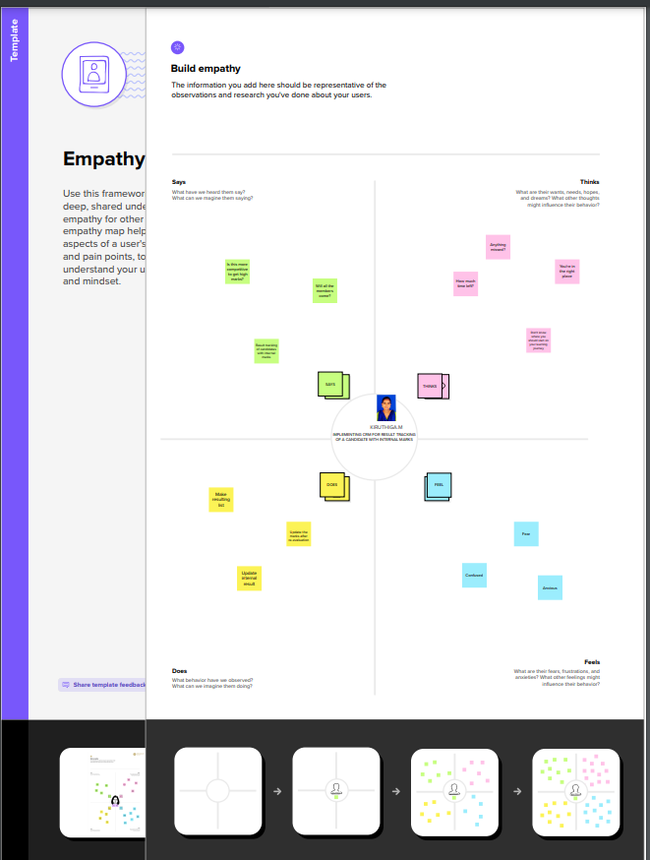

* 1. Ideation&BrainstormingMap

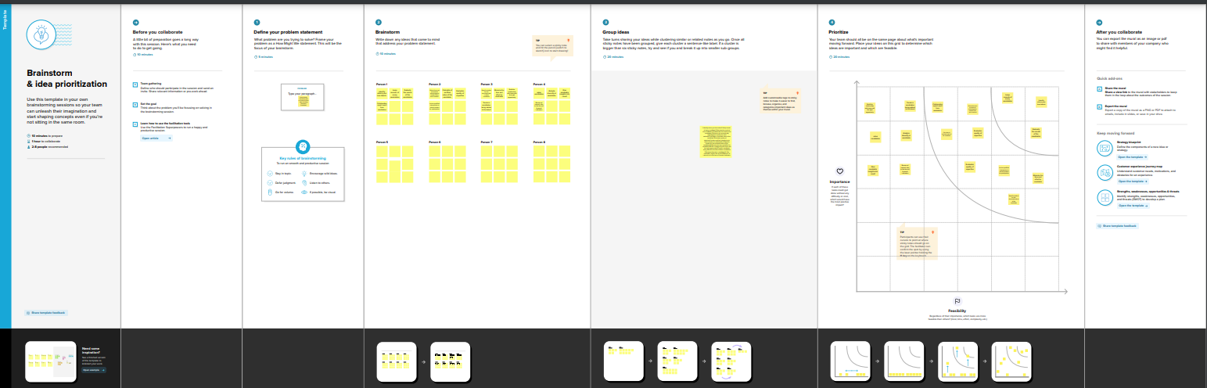

1. RESULT
   1. DataModel:

|  |  |
| --- | --- |
| **Objectname** | **FieldsintheObject** |
| obj1  1) semester  2) candidate | |  |  | | --- | --- | | Field label | Data type | | Semester name | Text | | Candidate name | Text | |
| obj2  3) Course Details  4) Lecturer Details | |  |  | | --- | --- | | Fieldlabel | Data type | | Course name | Text | | Lecturer Role | Text | |  |  | |

* 1. Activity&Screenshot

1.Go to salesforce.com and click on login.

2.Enter the username and password that you just created.

3.After login this is the home page which you will see..

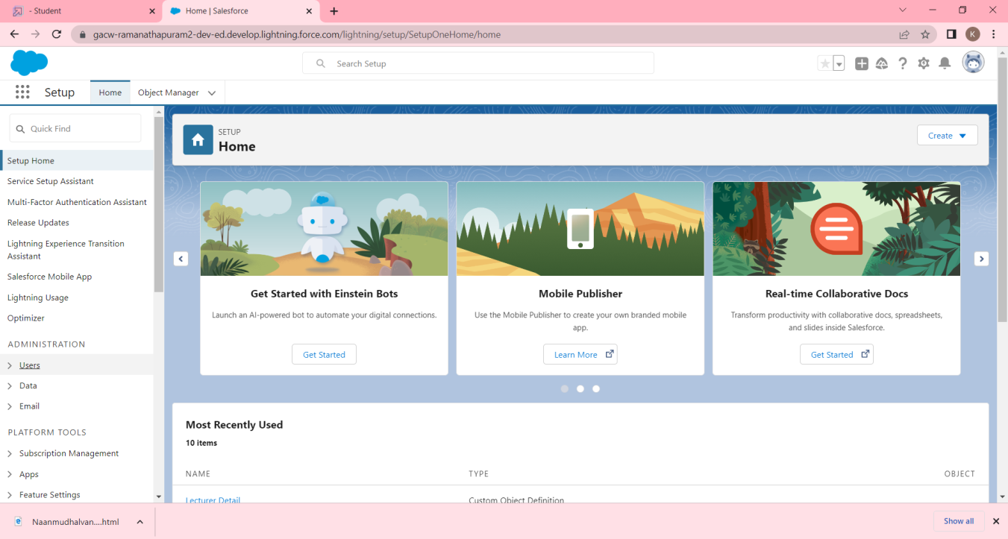

Salesforce objects are database tables that permit you to store data that is specific to an organization.

Custom objects:

1.Semester

2.Candidate

3.Course Details

4.Lecturer Details

5.Internal result

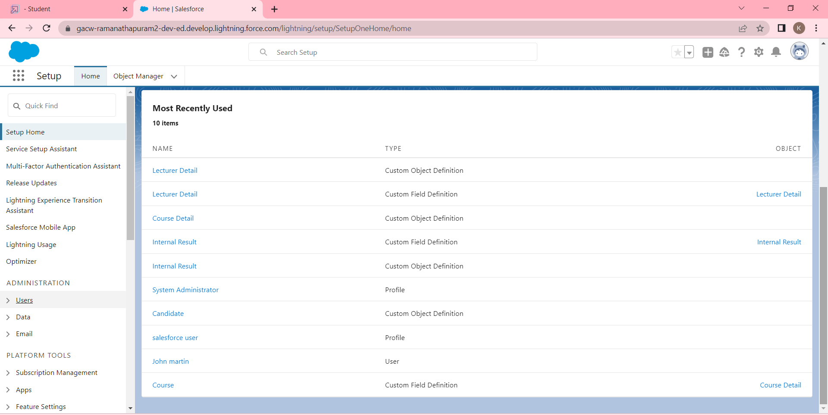  
 An object relationship in Salesforce is a two-way association between two objects. Relationships are created by creating custom relationship fields on an object. This is done so that when users view records, they can also see and access related data.

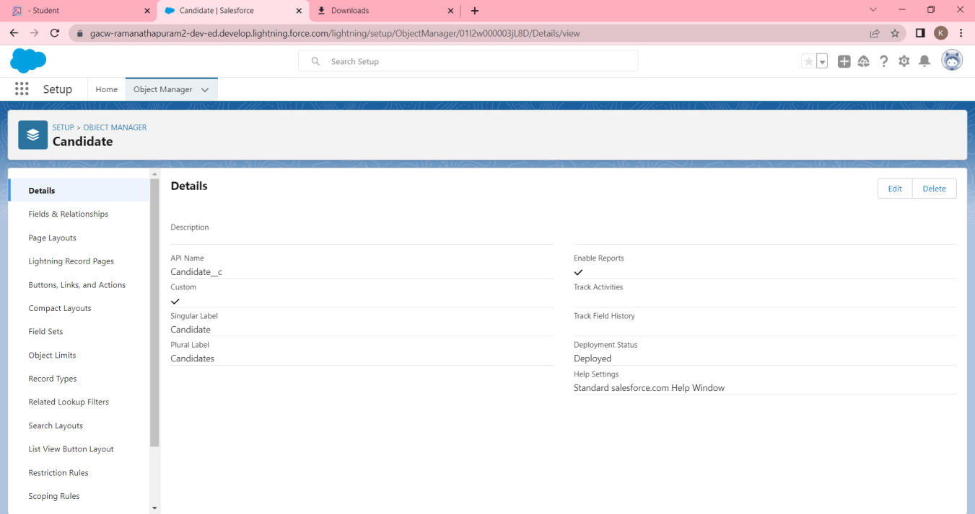

Apps in Salesforce are a group of tabs that help the application function by working together as a unit. It has a name, a logo, and a particular set of tabs. The simplest app usually has just two tabs.

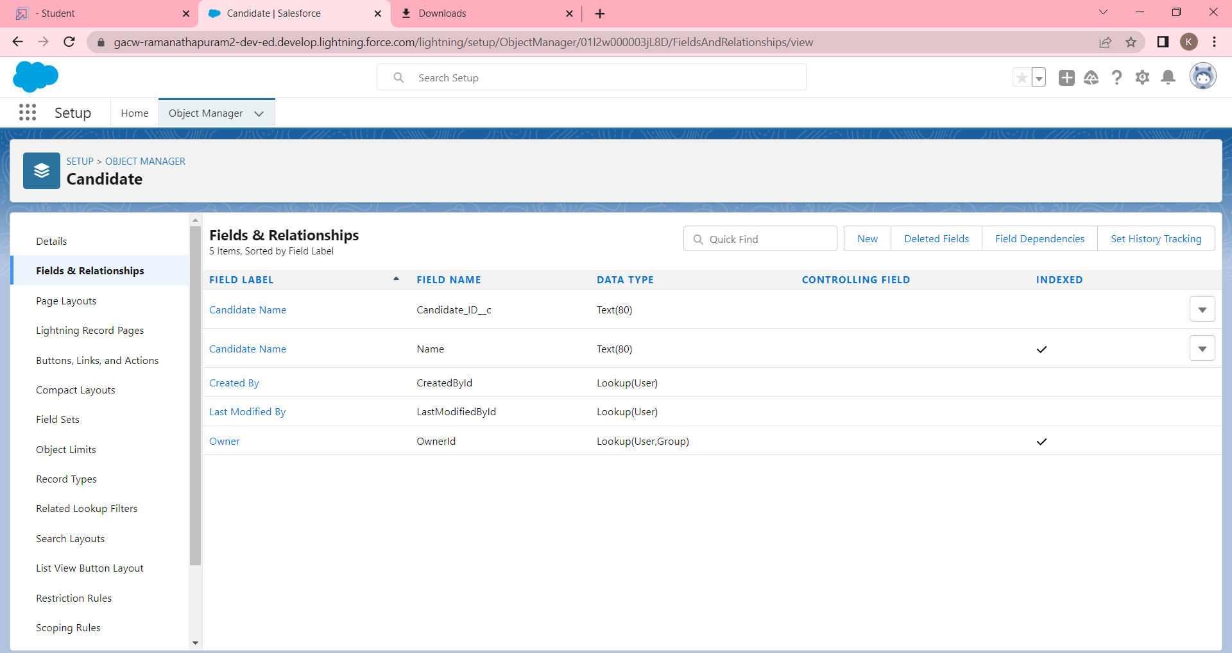

A user is anyone who logs in to Salesforce. Users are employees at your company, such as sales reps, managers, and IT specialists, who need access to the company's records. Every user in Salesforce has a user account.

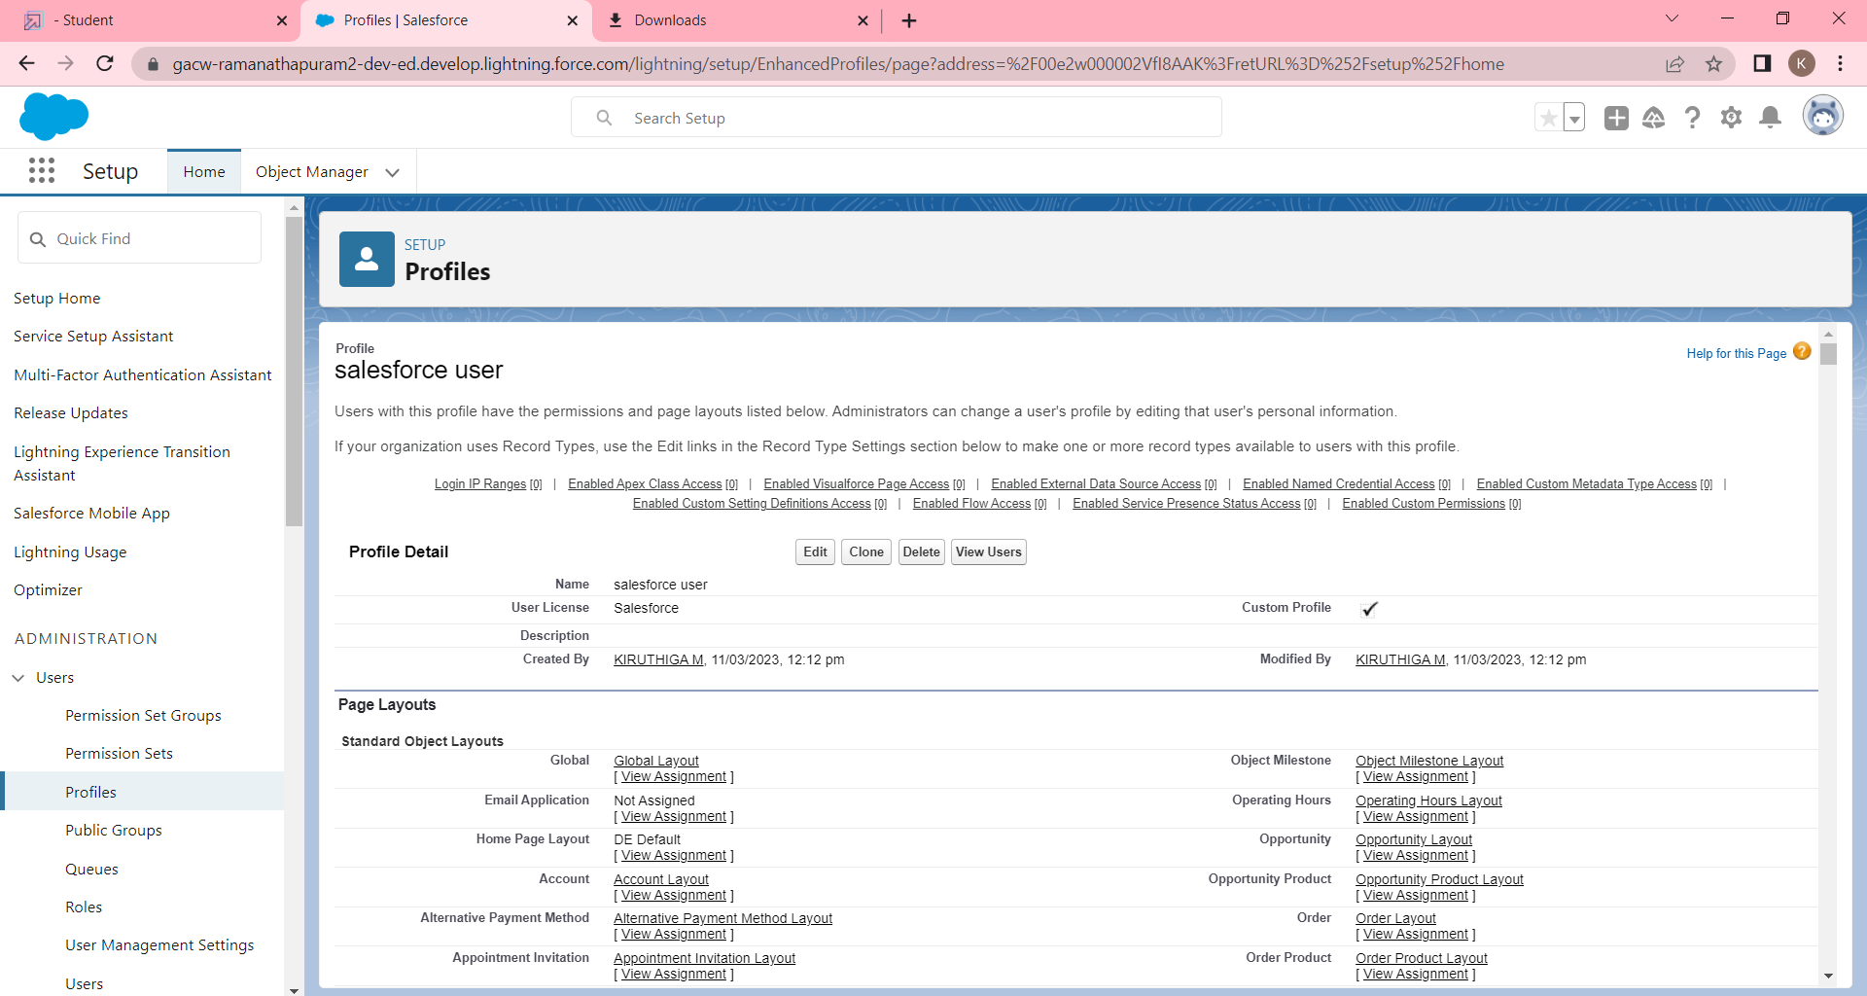

A report is a list of records that meet the criteria you define. It's displayed in Salesforce in rows and columns, and can be filtered, grouped, or displayed in a graphical chart. Every report is stored in a folder. Folders can be public, hidden, or shared, and can be set to read-only or read/write.

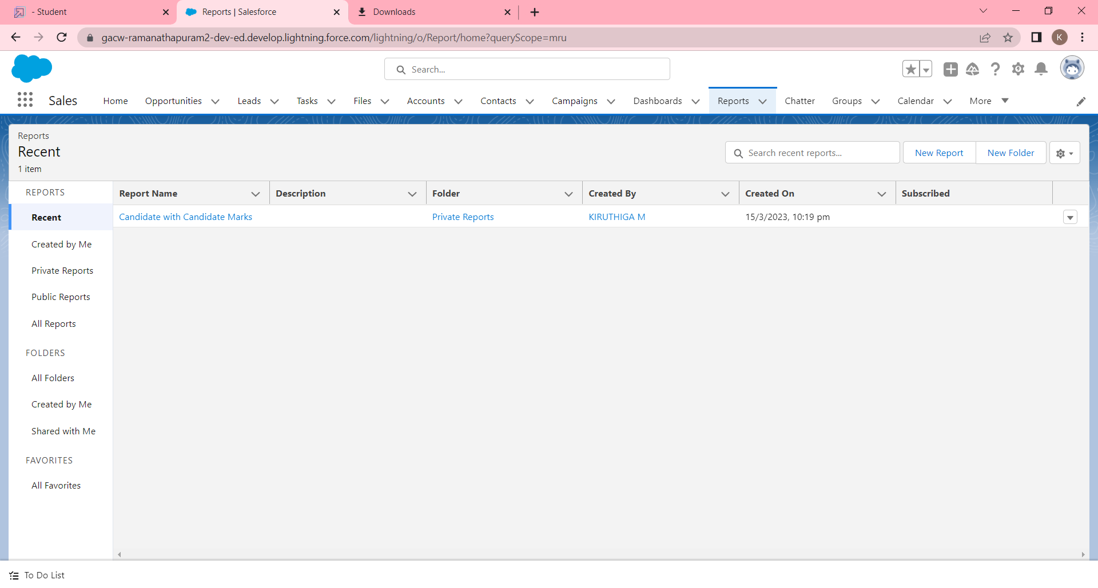

Dashboards let you curate data from reports using charts, tables, and metrics. If your colleagues need more information, then they're able to view your dashboard's data-supplying reports. Dashboard filters make it easy for users to apply different data perspectives to a single dashboard.

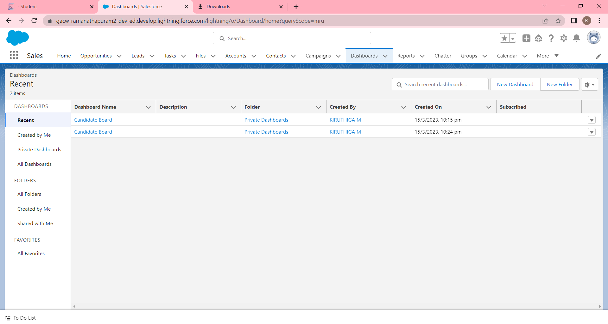

1. TrailheadProfilePublicURL

**Team Lead - https://trailblazer.me/id/kirum9**

**TeamMember1- https://trailblazer.me/id/rlegadharshini**

Team Member 2 -https://trailblazer.me/id/keera24

Team member 3- https://trailblazer.me/id/maria2002

1. **ADVANTAGES & DISADVANTAGE**

Technology has helped the business to reach its customers within a second. But more than interaction is needed in the long run, a business must maintain the satisfaction and happiness of its customers and it comes by solving their problem.

1. APPLICATIONS

you need to prepare and implement your CRM system right. And if your organization has many disparate systems, data sources, and complex processes, you may need to use professional CRM implementation services to ensure that all the data and workflows are mapped right. But in case you want to launch CRM rollout on your own, follow the guidelines below to guarantee project success.

1. CONCLUSION

Conclusion summarizing the entire work and findings is create object, field & Relationship, lightning app, users, Report, Dashboard.

1. FUTURESCOSE

1. Opportunity for exercising the faculties or abilities; capacity for action.

2. Oange of view, perception, or grasp; outlook.

3 .The area covered by an activity, topic, etc.; range.